LAB Assignment No 9
Distance-Based LED Control using Ultrasonic Sensor with ESP32 and ThingSpeak
In this lab, students will develop an IoT-based distance monitoring system using an ESP32 and an ultrasonic sensor. The system measures the distance of an object and classifies it into three ranges. Based on the detected distance, different LEDs will be activated. The measured distance will also be sent to the cloud using ThingSpeak for real-time visualization and monitoring.
Lab Objectives
- To interface Ultrasonic Sensor (HC-SR04) with ESP32
- To measure distance of an object
- To implement multi-level LED control logic
- To send distance data to ThingSpeak cloud
- To visualize distance data using cloud graph
Learning Outcomes
After completing this lab, students will be able to:
- Understand working of ultrasonic sensors
- Measure distance using ESP32
- Implement multi-condition logic (if-else)
- Control multiple LEDs based on sensor data
- Send IoT data to cloud platform
- Visualize and analyze distance data

Required Hardware / Software
Hardware
- ESP32 Development Board
- Ultrasonic Sensor (HC-SR04)
- 3 LEDs (LED1, LED2, LED3)
- 3 × 220Ω Resistors
- Breadboard & Jumper Wires
Software
- Arduino IDE
- Wokwi Simulator
- ThingSpeak Account

4. Circuit Diagram
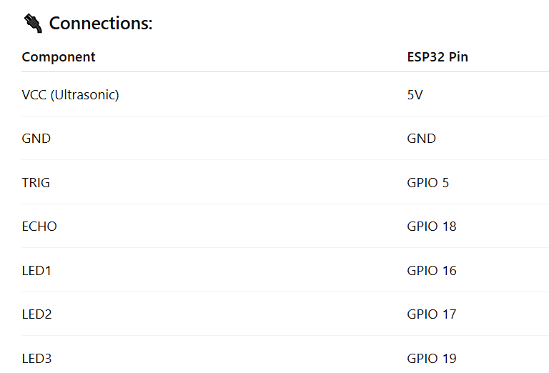
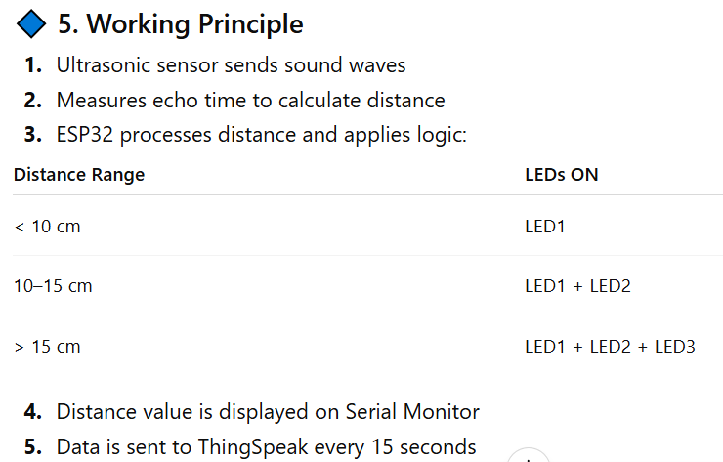

Program Code
#include <WiFi.h>
#include <ThingSpeak.h>

// WiFi credentials
const char* ssid = "Wokwi-GUEST";
const char* password = "";

// ThingSpeak
unsigned long channelID = YOUR_CHANNEL_ID;
const char* writeAPIKey = "YOUR_API_KEY";

WiFiClient client;

// Ultrasonic pins
#define TRIG_PIN 5
#define ECHO_PIN 18

// LED pins
#define LED1 16
#define LED2 17
#define LED3 19

void setup() {
Serial.begin(115200);

pinMode(TRIG_PIN, OUTPUT);
pinMode(ECHO_PIN, INPUT);

pinMode(LED1, OUTPUT);
pinMode(LED2, OUTPUT);
pinMode(LED3, OUTPUT);

WiFi.begin(ssid, password);
Serial.print("Connecting");

while (WiFi.status() != WL_CONNECTED) {
delay(500);
Serial.print(".");
}

Serial.println("\nConnected!");

ThingSpeak.begin(client);
}

void loop() {
// Trigger ultrasonic pulse
digitalWrite(TRIG_PIN, LOW);
delayMicroseconds(2);
digitalWrite(TRIG_PIN, HIGH);
delayMicroseconds(10);
digitalWrite(TRIG_PIN, LOW);

long duration = pulseIn(ECHO_PIN, HIGH);

// Calculate distance (cm)
float distance = duration * 0.034 / 2;

Serial.print("Distance: ");
Serial.print(distance);
Serial.println(" cm");

// LED Logic
if (distance < 10) {
digitalWrite(LED1, HIGH);
digitalWrite(LED2, LOW);
digitalWrite(LED3, LOW);
}
else if (distance >= 10 && distance <= 15) {
digitalWrite(LED1, HIGH);
digitalWrite(LED2, HIGH);
digitalWrite(LED3, LOW);
}
else {
digitalWrite(LED1, HIGH);
digitalWrite(LED2, HIGH);
digitalWrite(LED3, HIGH);
}

// Send data to ThingSpeak
ThingSpeak.setField(1, distance);

int response = ThingSpeak.writeFields(channelID, writeAPIKey);

if (response == 200) {
Serial.println("Data sent to ThingSpeak");
} else {
Serial.print("Error: ");
Serial.println(response);
}

delay(15000); // ThingSpeak delay
}

ThingSpeak Setup
- Create a channel
- Add:
  - Field 1 → Distance
- Copy:
  - Channel ID
  - Write API Key

Expected Outputs
🧪 Simulation (Wokwi)
- Distance changing dynamically
- LEDs turning ON based on distance
- Serial Monitor showing distance
📊 Cloud Output (ThingSpeak)
- Distance graph
- Real-time updates

Lab Tasks
Students must:
✅ Interface ultrasonic sensor with ESP32
✅ Implement 3-level LED control
✅ Display distance on serial monitor
✅ Send data to ThingSpeak
✅ Observe and analyze cloud graph

Deliverables
- Source code
- Wokwi simulation screenshot
- ThingSpeak graph screenshot
- Brief report

Viva Questions
- What is ultrasonic sensor?
- How distance is calculated?
- What is speed of sound used?
- Why divide by 2 in formula?
- What is ThingSpeak?
- Why delay is required?

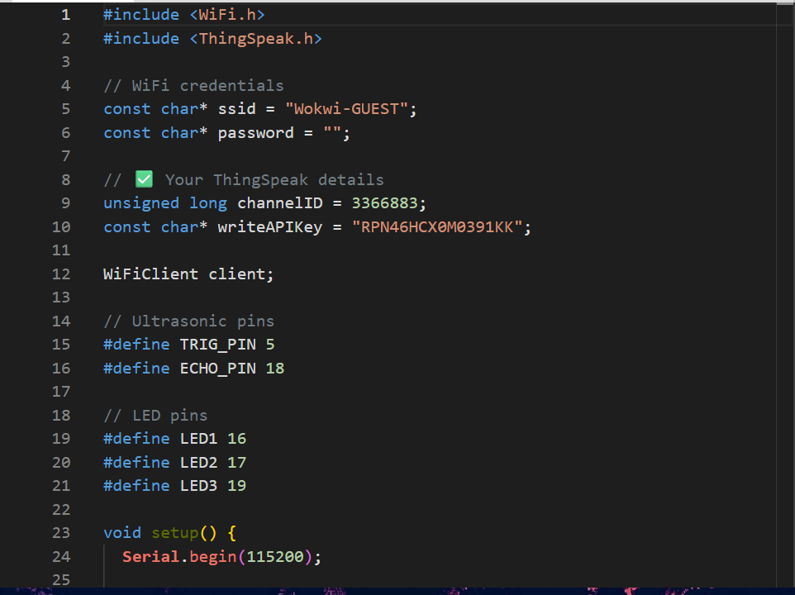
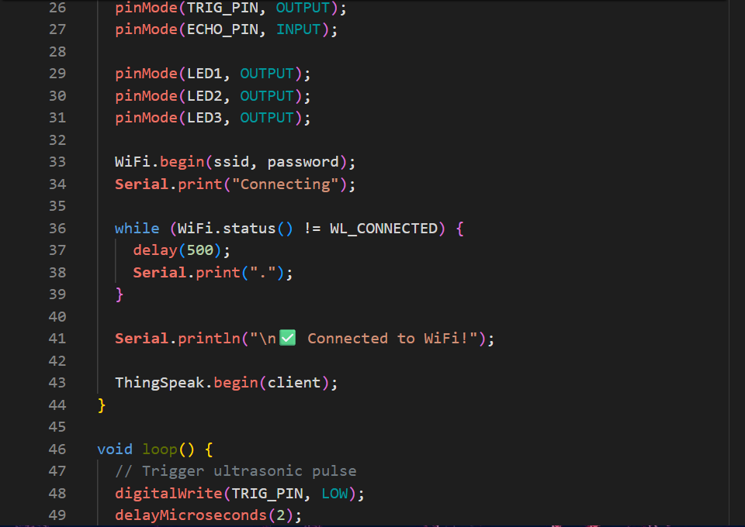
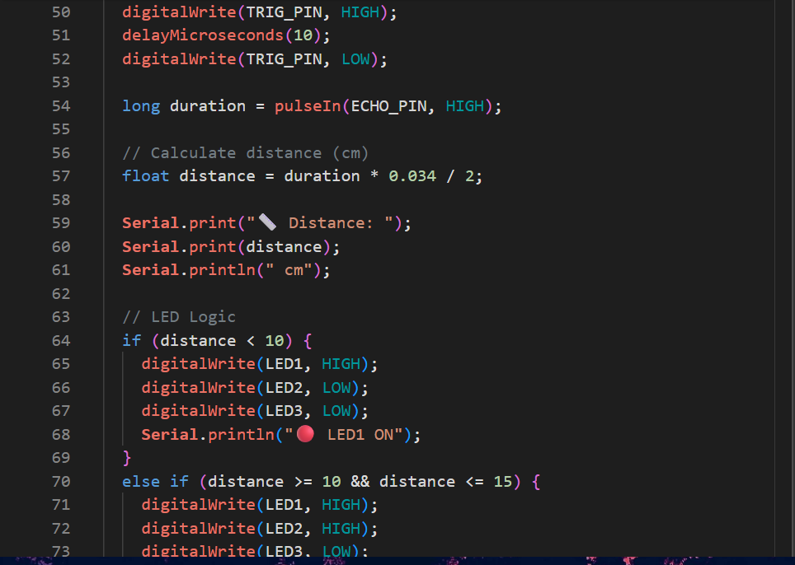
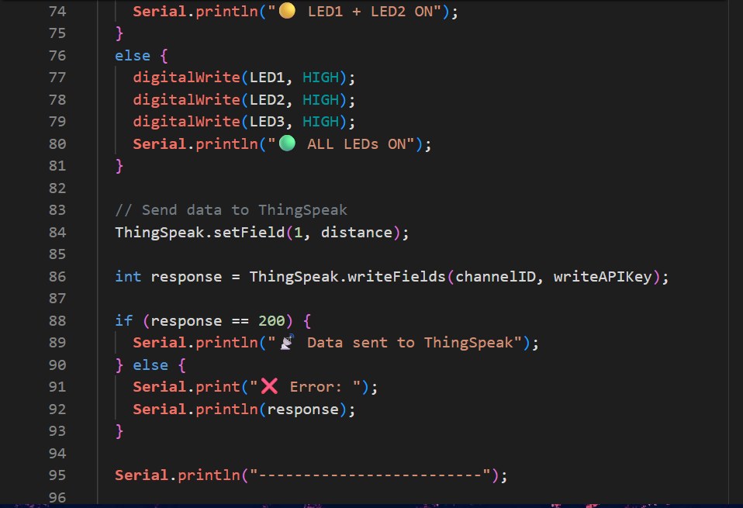
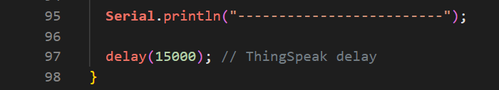
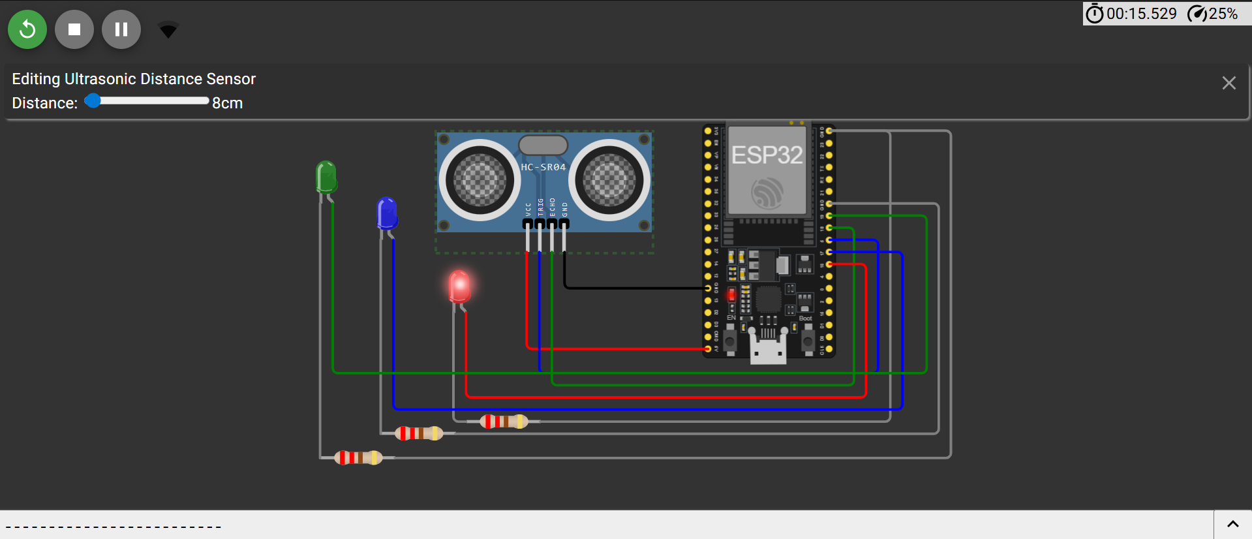
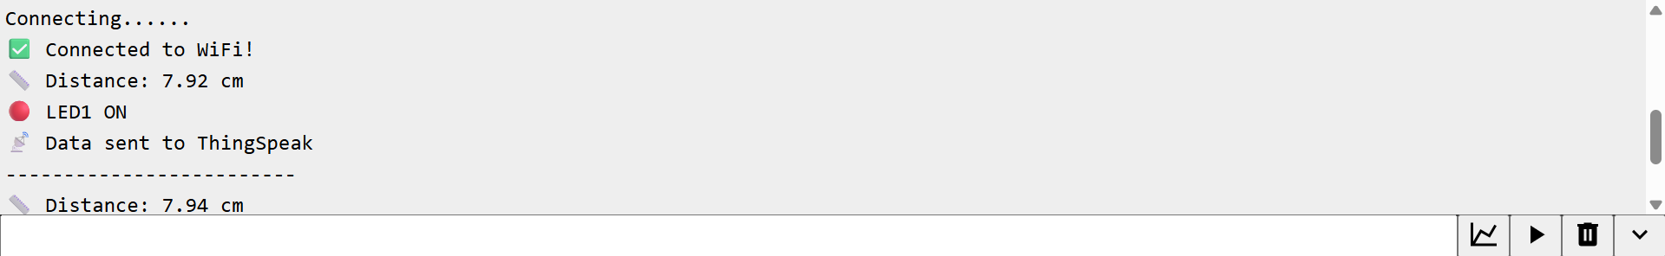
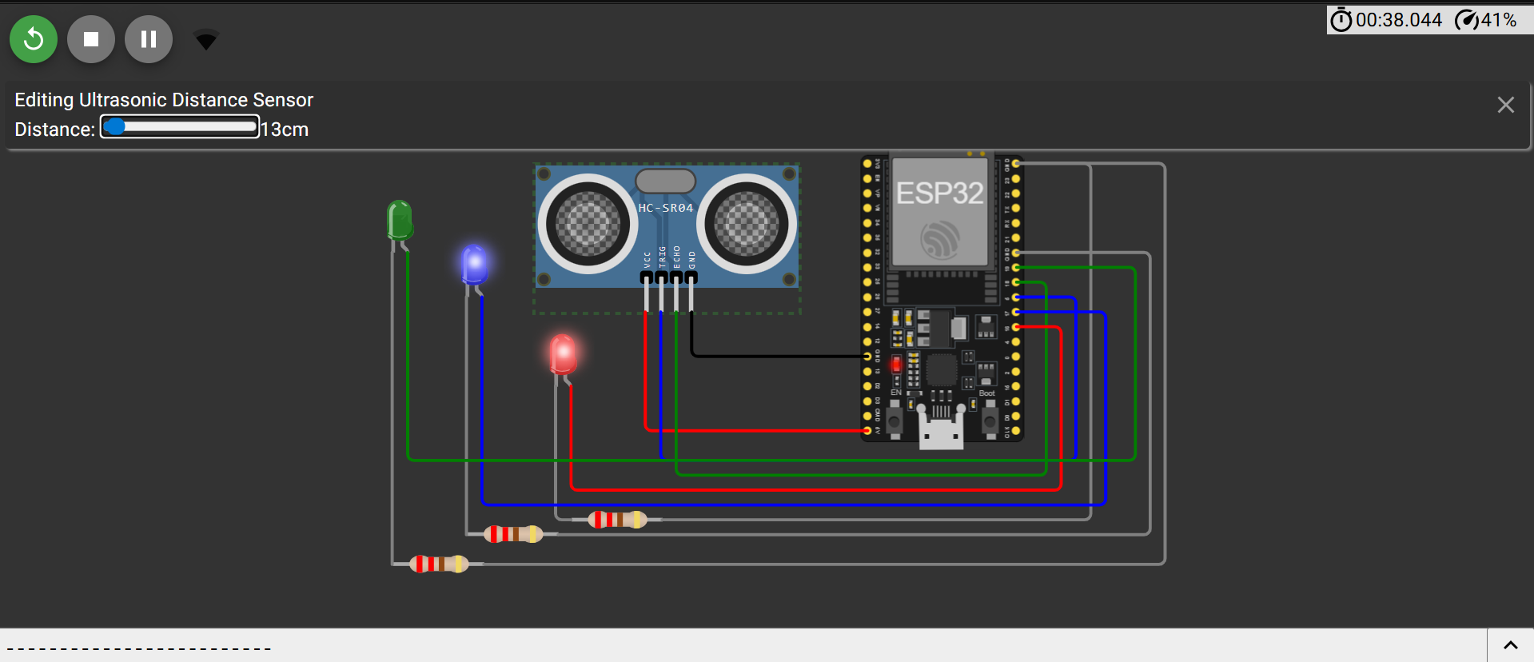
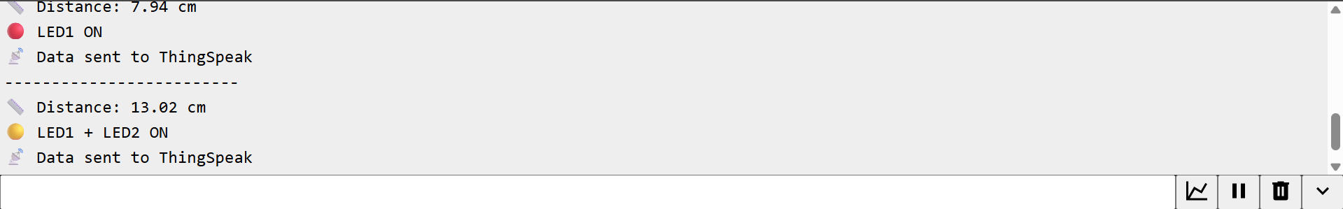
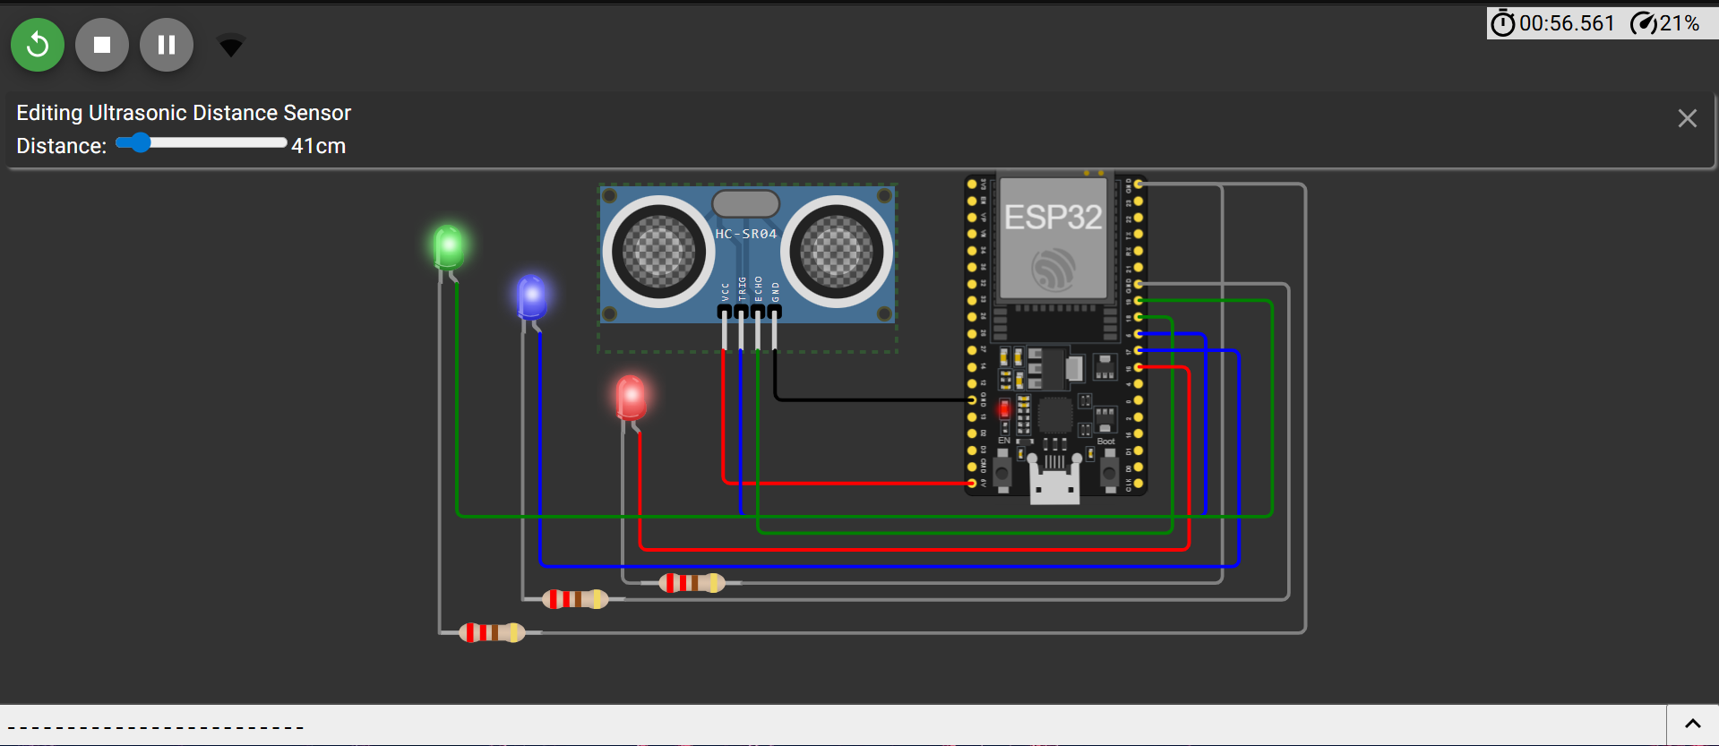
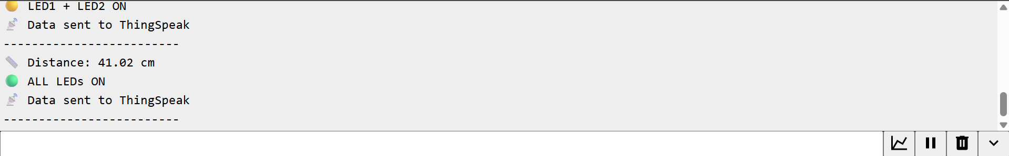
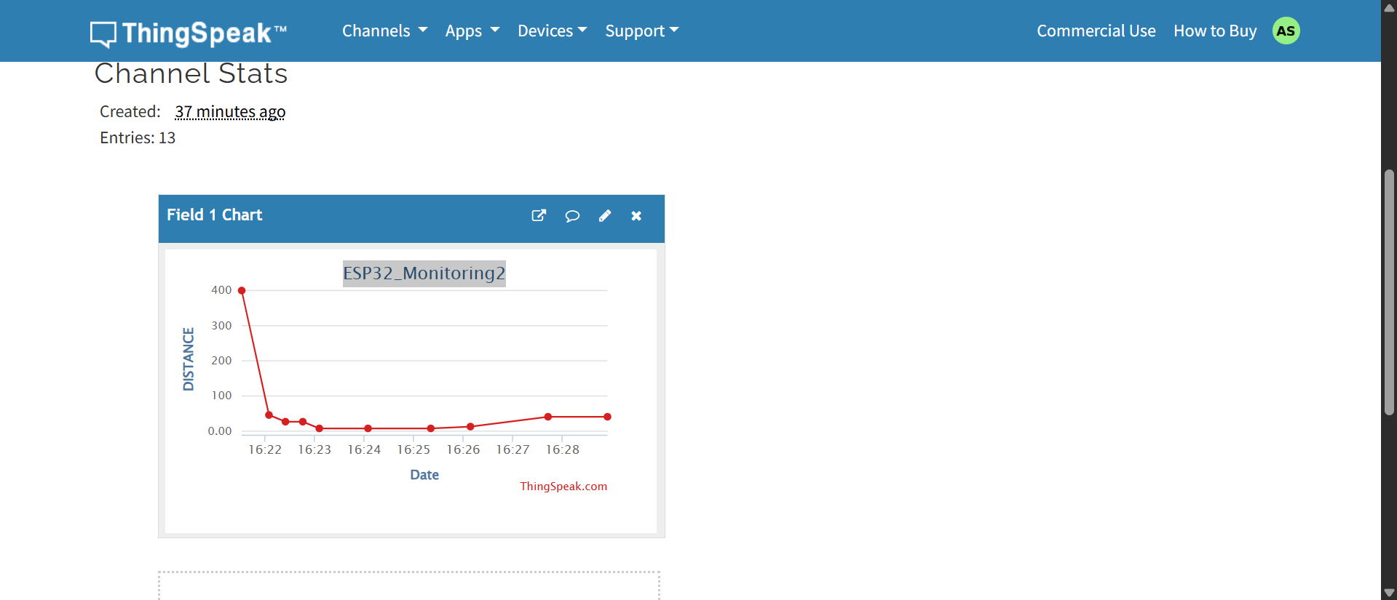

LAB Assessment

Student Name |  | LAB Rubrics | CLO3, P5, PLO5
 |  | Total Marks | 10
Registration No |  | Obtained Marks
 |  | Teacher Name | Dr. Syed M Hamedoon
Date |  | Signature

